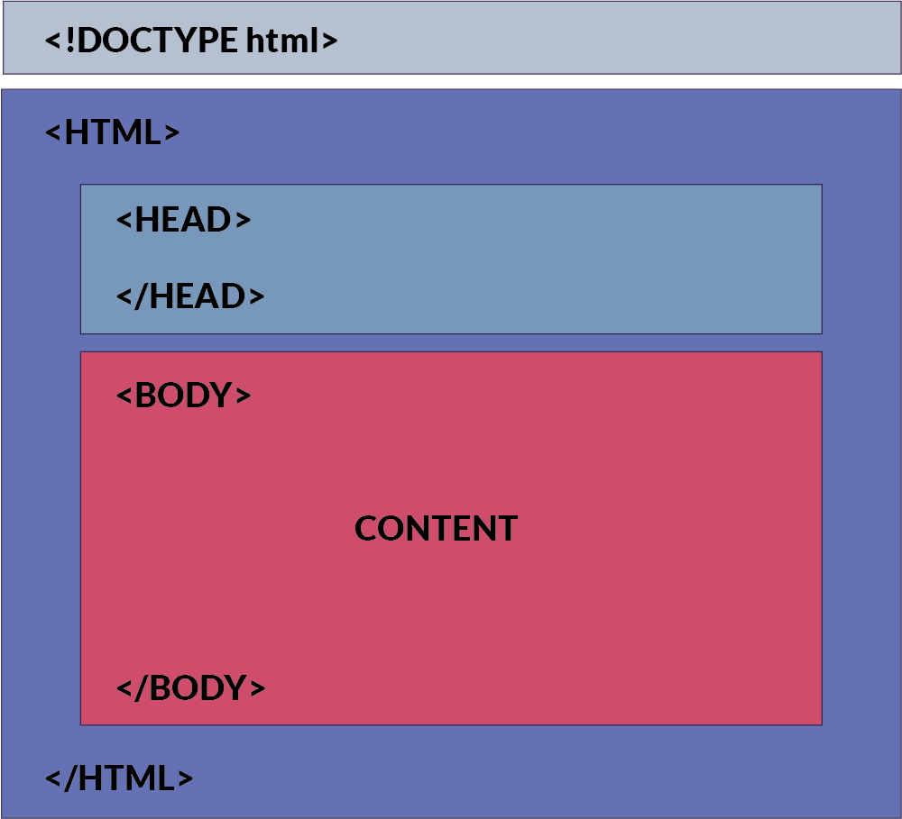
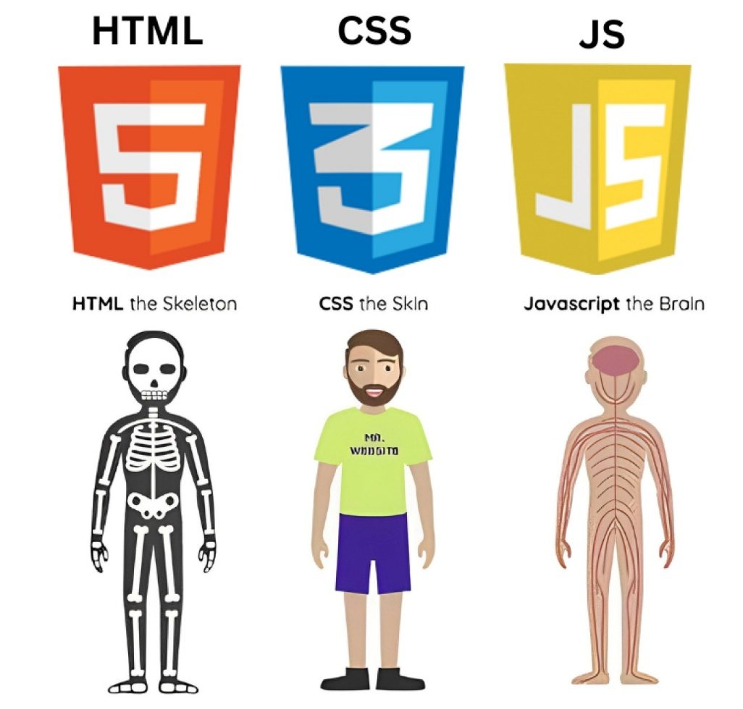
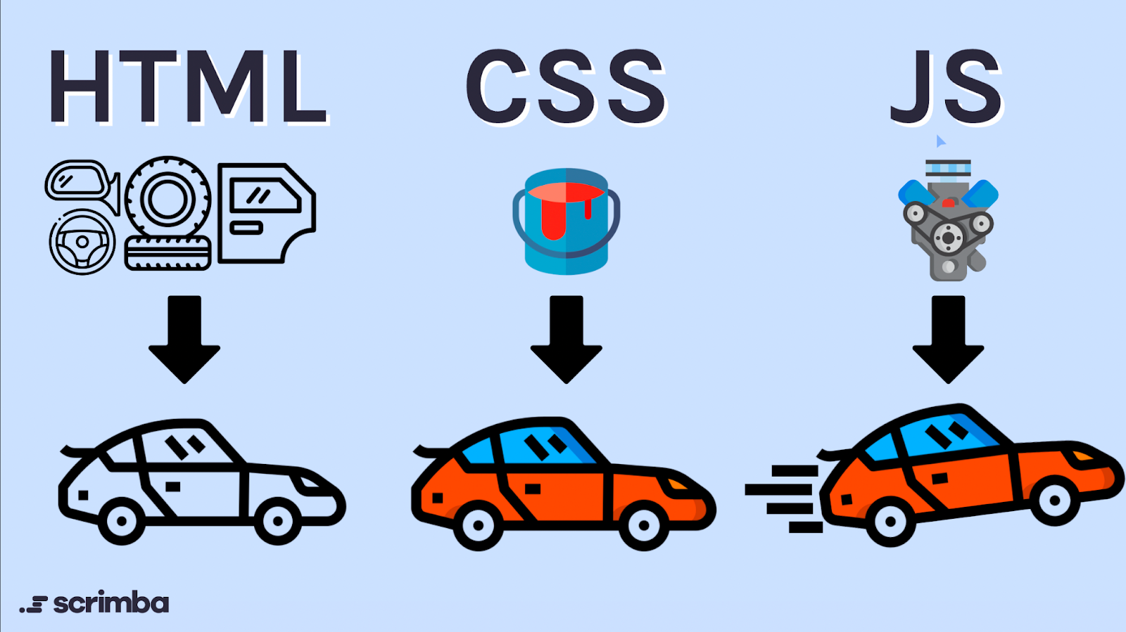
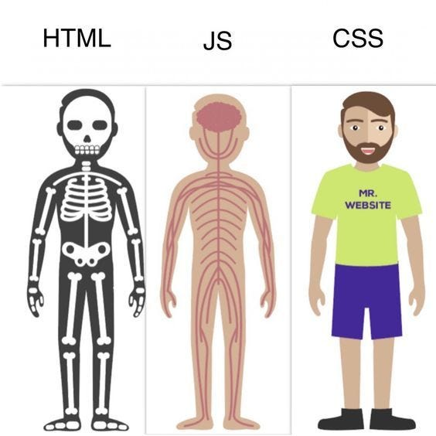
Below are TRAINER-LEVEL, STUDENT-FRIENDLY NOTES for HTML BASICS, written so you can explain confidently with visuals + real-world understanding.

1️⃣ HTML BASICS
HTML basics are the foundation bricks of every website.
If students understand this section clearly, everything else becomes easy.

🔹 What is HTML?
HTML (HyperText Markup Language) is the standard language used to create web pages.
HTML tells the browser:
✔ What content to display
✔ How content is structured
📌 HTML is NOT a programming language
It is a markup language (used for structure).
Example:
<p>Hello World</p>
➡ Browser understands this as a paragraph, not logic.

🔹 HTML History (Simple & Interview-Ready)
- Invented by Tim Berners-Lee
- First version released in 1993
- Major versions:
  - HTML 4
  - HTML 5 (modern standard)
Why HTML5 is important?
✔ Audio & Video support
✔ Semantic elements
✔ Mobile-friendly
✔ Faster & cleaner
📌 Interview Line:
HTML5 removed the need for Flash plugins.

🔹 HTML Structure (VERY IMPORTANT 🔥)
Every HTML page follows a fixed structure.
<!DOCTYPE html>
<html>
<head>
<title>My Website</title>
</head>
<body>
Content shown to user
</body>
</html>
Explanation:
Tag | Purpose
<!DOCTYPE> | Tells browser this is HTML5
<html> | Root element
<head> | Metadata (SEO, title, links)
<body> | Visible content
📌 Without proper structure, browser may break the page.

🔹 HTML Document Parts Explained
<!DOCTYPE html>
✔ Informs browser to use standard mode
✔ Avoids old browser quirks
<head>
Contains:
- Title
- Meta tags
- CSS links
- JavaScript links
⚠ Content inside <head> is NOT visible.
<body>
Contains:
- Text
- Images
- Buttons
- Forms
- Videos
✔ Everything users see is inside <body>.

🔹 HTML Editors
HTML can be written using any text editor, but professionals use:
✔ VS Code (recommended)
✔ Notepad
✔ Sublime Text
📌 Editor vs Browser
- Editor → writes code
- Browser → displays output

🔹 HTML File Extension
HTML files must end with:
.html
Examples:
index.html
about.html
contact.html
📌 Browser will NOT recognize file without .html.

🔹 HTML Comments
Comments are used to explain code.
<!-- This is an HTML comment -->
✔ Browser ignores comments
✔ Used for documentation
✔ Helpful for teamwork
📌 Interview Tip:
Comments do not affect page performance.

🧠 REAL-WORLD ANALOGY (STUDENTS LOVE THIS 🔥)
Website = Human Body
Technology | Role
HTML | Skeleton (structure)
CSS | Clothes (design)
JavaScript | Brain (logic & behavior)
📌 Without skeleton → body collapses
📌 Without HTML → website cannot exist

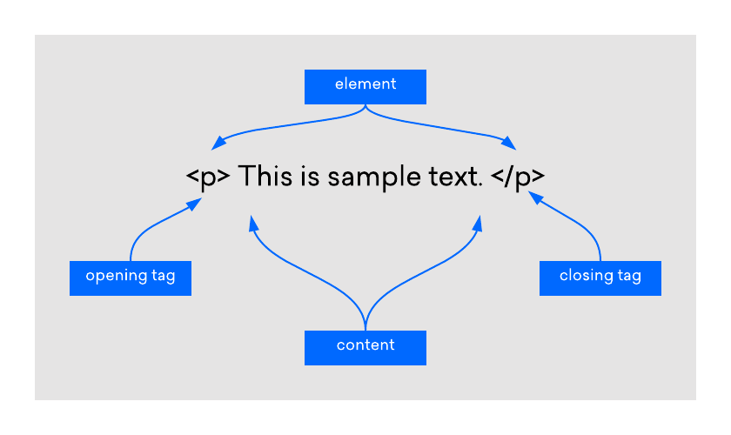

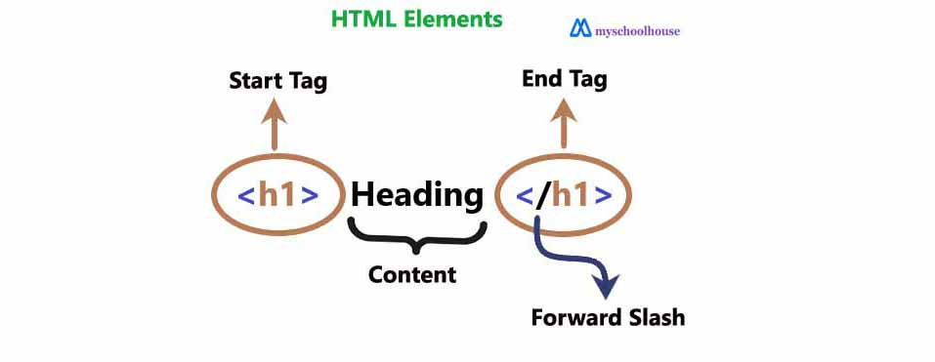

2️⃣ HTML ELEMENTS
Everything you see on a webpage is an HTML element.
🔹 What is an HTML Element?
An element is made of:
Opening Tag + Content + Closing Tag
<p>Hello World</p>
📌 <p> = element
📌 Hello World = content

🔹 Opening & Closing Tags
<h1>Heading</h1>
✔ Opening tag starts content
✔ Closing tag ends content

🔹 Empty / Self-Closing Elements
These do not have closing tags.
<br>
<hr>
<img src="image.jpg">
<meta>
📌 Called void elements in HTML5.

🔹 Nested Elements
Elements inside other elements.
<p>This is <strong>important</strong></p>
📌 Rules:
- Proper opening & closing order
- Clean nesting = valid HTML

🔹 Common HTML Elements
Tag | Purpose
<html> | Root element
<head> | Metadata
<body> | Visible content
<title> | Browser tab name
<meta> | SEO, charset
📌 Interview tip: <meta> has no closing tag.

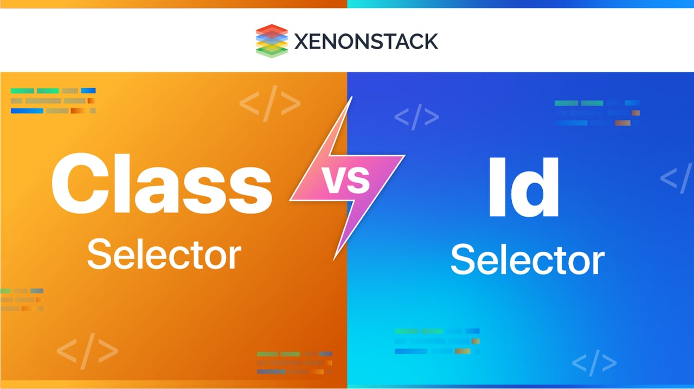

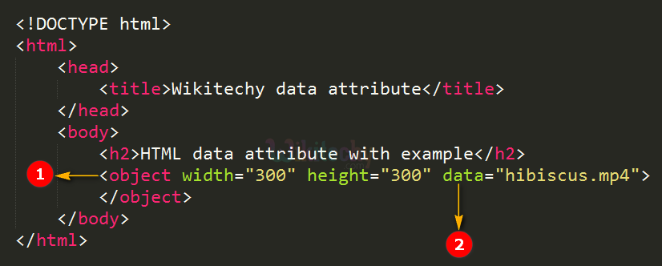
3️⃣ HTML ATTRIBUTES
Attributes provide extra information about an element.
<img src="car.jpg" alt="Red Car">
📌 Attributes are written:
- Inside opening tag
- As name="value"

🔹 Global Attributes
Work with almost all elements.
Attribute | Use
id | Unique identifier
class | Reusable style
style | Inline CSS
title | Tooltip text
hidden | Hide element
contenteditable | Editable text
draggable | Drag support
data-* | Custom data

🔹 id vs class
<div id="header"></div>
<div class="box"></div>
<div class="box"></div>
📌 ID = unique
📌 Class = reusable
⚠ Never repeat same ID.

🔹 data-* Attribute (INTERVIEW FAVORITE 🔥)
<button data-id="101">Click</button>
Used to store custom data without JS variables.

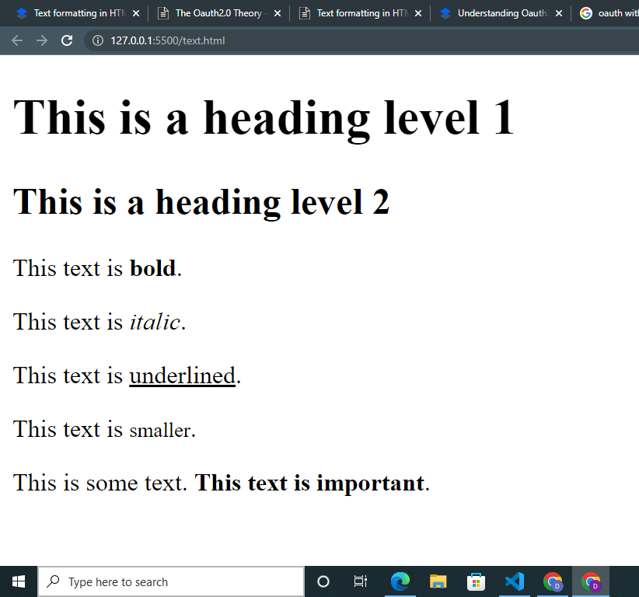

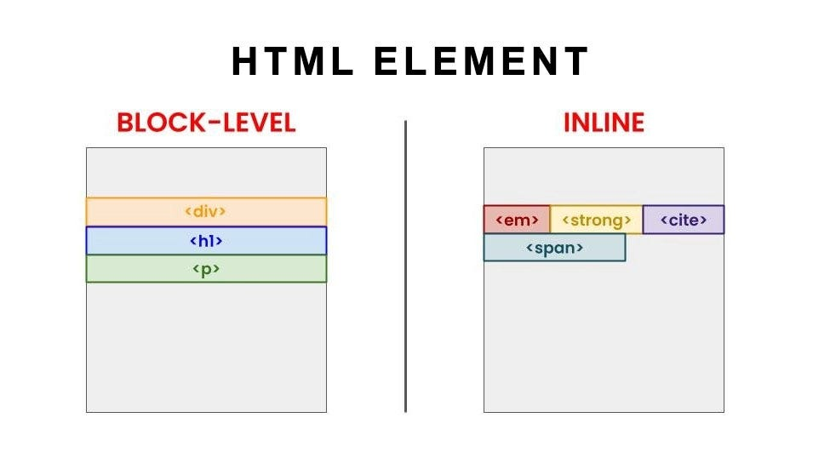
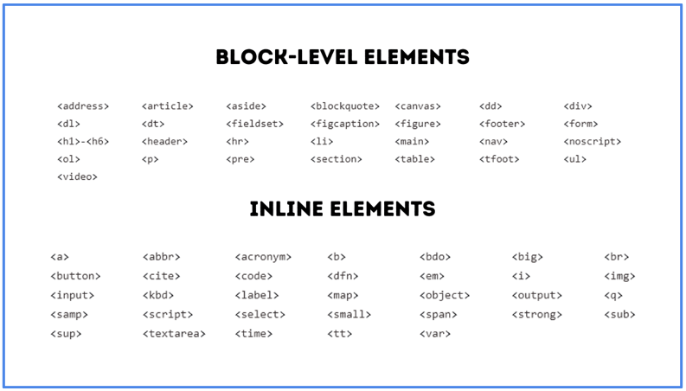
4️⃣ HTML TEXT & FORMATTING
Used to display and style text content.

🔹 Text Tags
Tag | Purpose
<h1>–<h6> | Headings
<p> | Paragraph
<span> | Inline text
<br> | Line break
<hr> | Horizontal rule
<h1>Main Title</h1>
<p>This is a paragraph</p>
📌 Only one <h1> per page (SEO best practice).

🔹 Formatting Tags
Tag | Meaning
<b> | Bold (visual only)
<strong> | Important (semantic)
<i> | Italic
<em> | Emphasis
<u> | Underline
<mark> | Highlight
<small> | Small text
<del> | Deleted text
<ins> | Inserted text
<sub> | Subscript
<sup> | Superscript
<p>This is <strong>important</strong></p>
📌 Interview:
<strong> is better than <b> for SEO & accessibility.

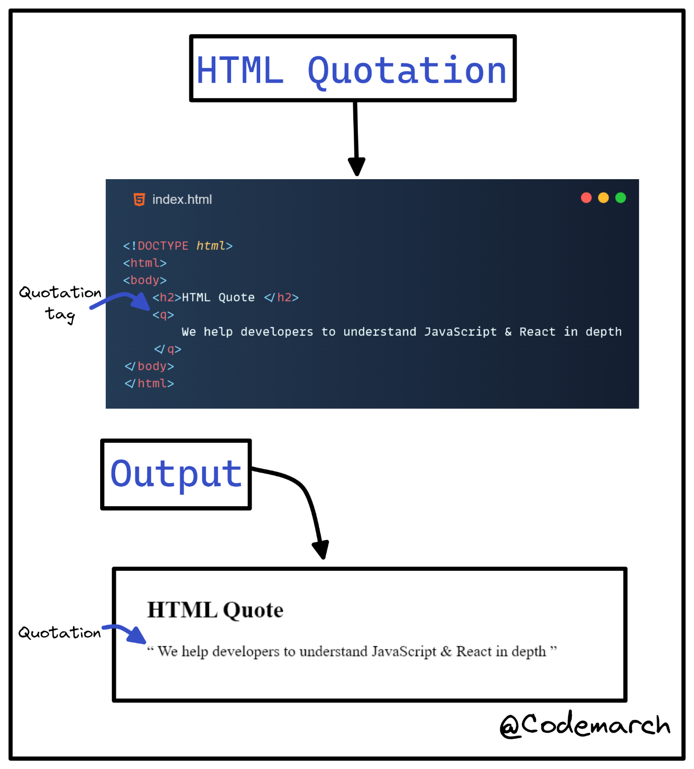
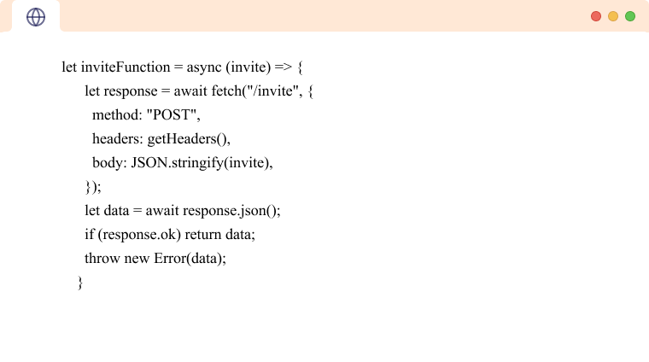
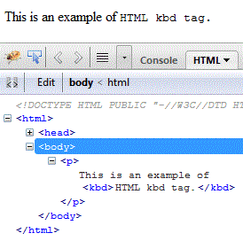
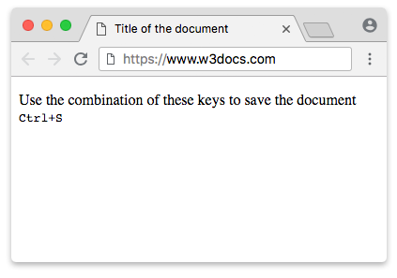
5️⃣ HTML QUOTATIONS & CODE
Used to display quotes, references & programming text.

🔹 Quotation Tags
<blockquote>This is a long quote</blockquote>
<q>Short quote</q>
Tag | Use
<blockquote> | Long quote
<q> | Inline quote
<abbr> | Abbreviation
<cite> | Reference
<address> | Contact info

🔹 Code & Programming Tags
<code>console.log()</code>
<pre>
function test() {
return true;
}
</pre>
Tag | Purpose
<code> | Code snippet
<pre> | Preserved format
<kbd> | Keyboard input
<samp> | Output
<var> | Variable
<bdo> | Text direction
📌 <pre> preserves spaces + line breaks.

